To: The Record

From: Don Bellenger

Subject: Set up ssh to use git repositories at Keymind

Date: October 23, 2013

At KeyMind, there is a jfas project, which contains three repositories: jfas, jfasdd, and jfas_docs. A person who can set up these repositories is Jovett Diala, [jdiala@keymind.com](mailto:jdiala@keymind.com), 703.280.9410 x112.

BEFORE using the ssh links below, you must create three files (found this by Googling git bash private key):

* a private Putty key without a passphrase, for Tortoise git
* an OpenSSHKey with a passphrase, for msysgit, which is used in “git bash here”
* a public key, to send to a stash administrator, to register you in the Keymind server

Keys must be stored in your home directory - which at DOL is H:\ - in an .ssh subdirectory.

Download the puttyGen Suite (putty.zip) for Windows Intel x86, and install). It is at <http://www.chiark.greenend.org.uk/~sgtatham/putty/download.html>

Run puttyGen (part of the putty suite). Click “Generate”. Do not enter a passphrase.

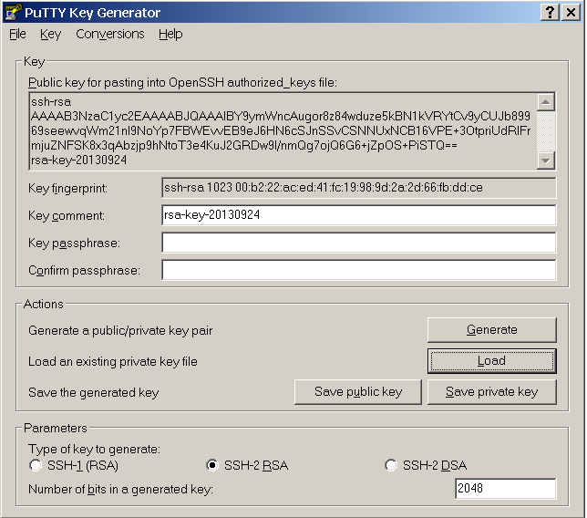

Click “Save Public Key” and save as H:\.ssh\git_public_key.pub. Click “Save private key”, and save as git_private_key.ppk. Then add your passphrase, so you won’t have to enter a login every time you use msysgit in “Git Bash Here”. Then click conversions, Export Open SSH key, and save the Open Key with the passphrase, as “H:\.ssh\id_rsa”. Here is a final result.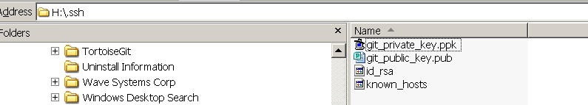

The public key – git_public_key.pub - must be emailed to Jovette Diala, for installation into the Keymind jfas project. There is a different public key for each user. Associated with the public key, you must have a login to access the JFAS project, which contains the jfas and the jfas_docs repositories.

Once you have access to the KeyMind server, you can use the following command in Git Bash to clone to the git repository at KeyMind for jfas. The first “jfas” in the string is the project, the second is the repository.

git clone ssh://git@stash.keymind.com:7999/jfas/jfas.git

Here is the command to link to the git repository at KeyMind for jfas_docs

git clone ssh://git@stash.keymind.com:7999/jfas/jfas_docs.git

Here is the command to link to the git repository at KeyMind for jfasdd

git clone ssh://git@stash.keymind.com:7999/jfas/jfasdd.git

Putting this together, the test that all this is working for jfas_docs is to go to H:\My Documents. Right-click, and select Git Clone. Complete the form. (Note that ssh:… is required, although not in the screen shot)

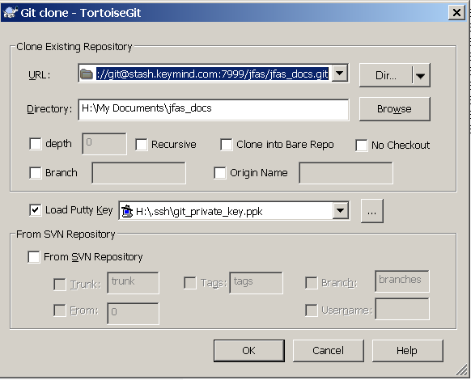

To see if Git Bash is working, make a junk directory somewhere else. Highlight, right-click, and select Git Bash Here. Type the clone command as shown below, and enter the passphrase when requested. (Note, the screenshot below is for jfas, but you get the idea).

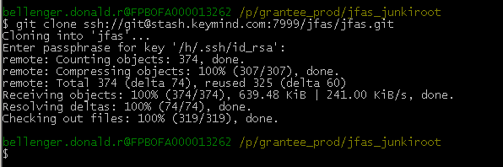

-end-